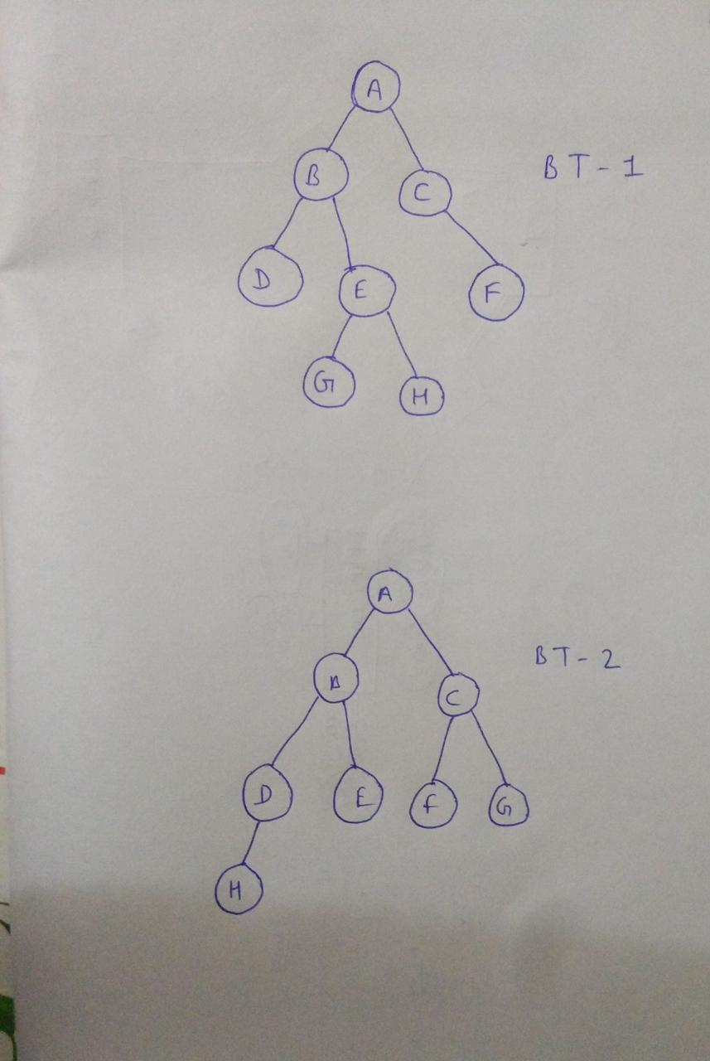

**PREORDER: A B D E G H C F**

**POSTORDER: D E G H B F C A**

**INORDER: D B G E H A C F**

**LEVEL ORDER: A B C D E F G H**

**NOT A FULL OR COMPLETE BINARY TREE**



**PREORDER: A B D H E C F G**

**POSTORDER: H D E B F G C A**

**INORDER: H D B E A F C G**

**LEVEL ORDER: A B C D E F G H**

**COMPLETE BINARY TREE**